**Half day consultation on SDG and goal #16 in particular on Sunday, 15 January** **2017 Singapore**

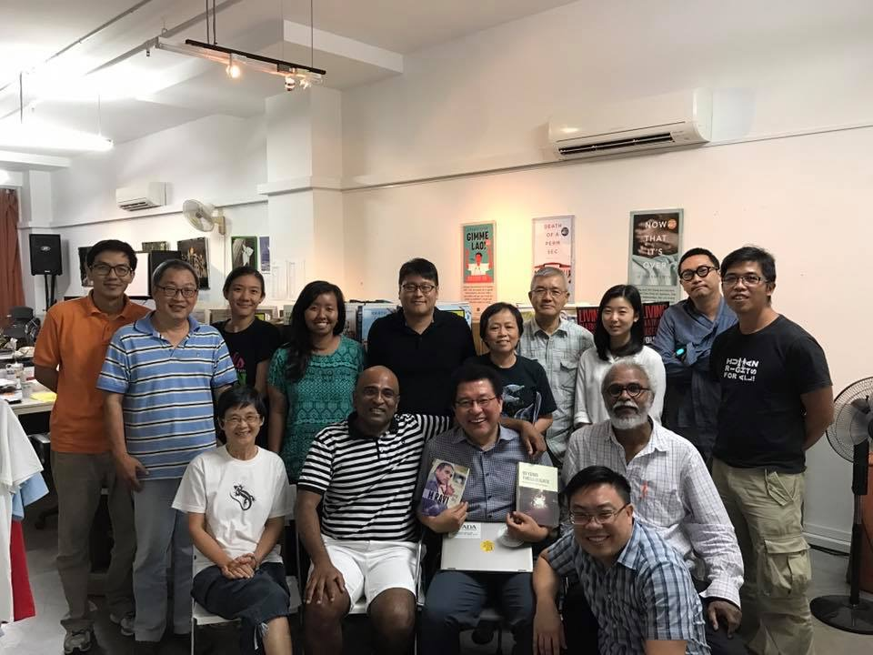Asia Development Alliance (ADA) along with its partners Asia Democratic Network (ADN) and ALMOS - Alliance of Like-Minded CSOs in Singapore (ALMOS) a network of CSOs working on UPR and SDGs in Singapore including a group called "Function 8", mainly former political prisoners, organized a half day consultation on SDG and goal #16 in particular on Sunday, 15 January 2017 at 2.30 - 5pm at The Agora, #03-142, 28 Sin Ming Lane, Midview City, 573972, Singapore. The meeting had the following **objectives**:

* to assess the state of Singapore government's commitment to SDG domestic implementation,
* to assess and come up with the action plans and strategies for CSOs in Singapore on SDG implementation including goal 16,
* to come up with strategies and action plans for cooperation between CSOs /ALMOS and ADA and ADN on international solidarity campaign in Asia, such as Cambodia, Myanmar (Rohingya), etc.

**Output:** The ALMOS including Think Centre and Function 8 (F8) and other concern groups will be meeting again to follow-up on the proposed calendar of activities